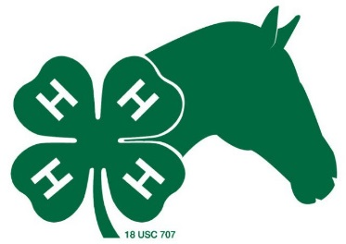

Nassau County/Florida 4-H Horse Program Qualification Application
Due by December 31st
All information must be filled in order for form to be considered.
A new or updated form is required each year.
Each time you change project horse during the year you need to complete a new Application Form.

4-H Member’s Name:

4-H Club: _____________________ Birthdate: _______ - _______ - _______
Month Date Year

Mailing Address City State Zip Phone E-mail
Animal Identity:

Name of Horse: ____________________________________ Also Known As: _____________________
(as shown on coggins & registration papers)
Color __________________________ Gender (circle one) Gelding Mare Age ___________
Weight Height _________

Special Markings Registered: Yes No Reg #: Grade/Breed:
Date Acquired as a 4-H Project

Please indicate which type(s) of riding style(s) that you plan to participate in this year. Check as many as appropriate:
Dressage English Jumping Ranch Speed Trail Western

I certify that the information above is accurate and that this animal meets minimum requirements set forth on reverse side of this form. I understand that this certificate may be revoked if upon later inspection the animal does not meet requirements set forth on reverse side. I have read the Nassau County 4-H Horse Project Rules and agree to abide by them for Area Show eligibility.

Signature of Applicant Date

I certify that this animal has been inspected and found to fit the description above and meets the requirements set forth on the reverse side of this form. The animal is managed by the 4-H’er named above and is his/her 4-H project horse. I have read the Nassau County 4-H Horse Project Rules and agree to abide by them for Area Show eligibility.

Signature of Parent or Guardian Date

For county level activities horse ownership is not required. These members, however, cannot participate beyond county level unless the non-owned horse is a 4-H project horse that is leased and all requirements set forth in the Florida 4-H Horse and Pony Lease Agreement (4-H 514) have been satisfied and on file in the 4-H Office.

Signature of Horse Owner is Required: I grant permission to (4-H’er)
to use my horse in all phases of the 4-H Horse Program.

Owner’s Signature Date

****Refer to other side for procedure and requirements. Form edited 10/24/2017****

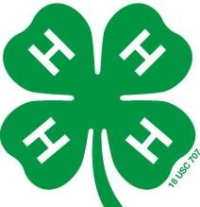

Procedure

- Type or print attached form in order to qualify to participate in the Nassau County Horse Program. All parties must have signed at the appropriate places.
- If a horse is LEASED, Form 4-H 514 must be filled out and turned in to the 4-H Office with the application.

- Attach photographs:
        - 2 color photos
        - Approximately 3 ½ x 3 ½
        - One of each complete side of the horse
        - Include face in at least one of the photographs
        - Do not include any equipment or persons in the photographs

- Obtain verification from 4-H Club Leader or Extension Agent

- Leader must return the required forms to the Nassau County 4-H Office/ 4-H Agent no later than December 31st. Considerations/exceptions will only be given to new Nassau 4-H members wishing to participate in the horse program.

Requirements

1. Must be an active and current 4-H club member, meeting all the membership requirements established by the club and county program.

2. Manage at least one horse of any age or breed as a 4-H horsemanship project. (No more than three horses can be on file per 4-H’er.)

3. The required forms must be in to the 4-H Office by December 31 of current year.

4. The horse must be certified as a 4-H project to participate in the Nassau County Horse
Program.

5. Participants/parents must comply with the Nassau County HP Code of Conduct and
Commitment.

6. Counties may allow for replacement of a project horse or pony that is not registered or not registered prior to the Area Show only if the project horse or pony is certified unsound by a veterinarian and approved by the County Extension Agent.

7. The 4-H member must keep and submit to the county 4-H Agent a Nassau County 4-H Horse Project Record Book on project horse(s).

