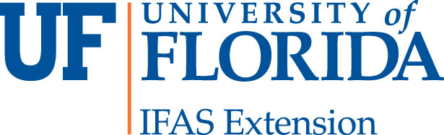

_____________________________________________________________________________
Nassau County Extension Office
543350 U.S. Highway #1
Callahan, FL 32011
(904) 530-6353 (904) 530-6351
http://nassau.ifas.ufl.edu

Landscape Matters
Holiday Mailbox Decorating
Wednesday November 15, 2017
10:00AM-11:30AM
Class Registration
1. NAME: Mr. Mrs. Ms.
2. ADDRESS:
3. CITY ZIP CODE:
4. HOME PHONE: CELL PHONE:
5. EMAIL:
6. FEE ENCLOSED: $ _____________

Make your mailbox “holiday ready” using cuttings from your own yard, e.g., magnolia, spruce, pine, palmetto, pittosporum, palms, holly with berries, etc. and ornamental decor. Admittance is free. To "make and take" your own mailbox cover with materials provided by the instructor, the fee is $20. Checks should be made out to University of Florida. Registration deadline is Friday, November 10 by 5pm. (It is a holiday for Extension but checks may be dropped in the mail slot at the offices either in Callahan or Yulee.) Late registration fee is $30. Only ONE mailbox cover per person.

Nassau County Extension - Callahan Office, 543350 US Hwy 1, Callahan, FL 32011-6486
Phone: (904) 530-6353
Nassau County Extension - Yulee Office, 86026 Pages Dairy Rd, Yulee, FL 32097
Phone: (904) 530-6351, FAX: (904) 548-1465

The Institute of Food and Agricultural Sciences (IFAS) is an Equal Opportunity Institution authorized to provide research, educational information, and other services only to individuals and institutions that function without discrimination with respect to race, creed, color, religion, age, disability, sex, sexual orientation, marital status, national origin, political opinions, or affiliations, USDA, UF/IFAS Extension, FAMU and Boards of County Commissioners Cooperating.

