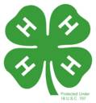
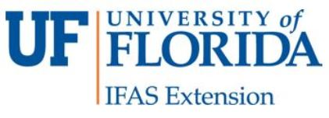
4-H Adult Volunteer Evaluation
University of Florida/IFAS Extension – Holmes County 4-H

Ready-to-Go Cloverbud Science Kits – Post Reflective Volunteer Survey

Please select the appropriate response by checking the box to the right of the question.  This Ready-to-Go Cloverbud Science Kit… | Strongly  Agree | Agree | Disagree | Strongly  Disagree
- Provided a way to explain a science concept to youth.
2. Clearly illustrated a scientific concept to youth.
As a result of participating…
3. Youth are able to demonstrate science skills.
4. Youth are able to verbally state scientific observations.
5. Youth developed an interest in science.
In one or two sentences, complete the following:
The most important thing youth learned is…
One Thing You Might Change for the Next Time…

One Thing You Should Definitely Keep for Next Time:

Information About You:
Date: M: ___ F: ____ Age: _____ Ethnicity: # of Years in 4-H:

