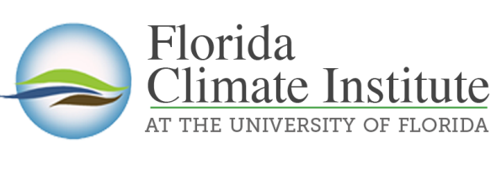
2021-2022 Florida Student Climate Fellows
What: A new opportunity for undergrad and summer grad students to earn a stipend for engaging in a climate-related research project with a faculty mentor. Each fellow can earn up to $2500, $500 of which would go to the faculty mentor to oversee the project.
Why: To engage students in climate-related research, education, communication, outreach, and projects that help enable communities to take action to adapt to the impacts of a changing climate.
- To learn climate research and action skills through mentored projects.
- To understand how climate research can impact communities.
- To forge coordinated relationships with community leadership.
- To establish a network of climate leaders at all levels.

Who: Undergrads or summer grad students from any college or program who will bring energy, commitment, and drive to support communities across Florida address climate-related impacts while gaining research experience. Undergrads may not graduate before May of 2022. Grad students can propose a funded summer research project.

How: Each prospective fellow must submit the application, a 1 to 2-page proposal outlining their plans, and a letter of commitment from their faculty mentor who will oversee the work that includes:

- A detailed plan for their proposed research project including a problem statement, proposed solutions, products or tools to be developed, potential broader impacts, and a budget for how the $ would be spent.
- A letter from the supervising faculty mentor stating the merits of the proposal and the student fellow
- While each proposed project may not be focused on Florida, the outputs must address how the work can apply to communities in Florida.
- In addition to the outlined plans, each fellow must agree to participate in an event on campus in spring 2022 to share their experience, findings, summary of work, potential for future funding, and next steps.

When: Applications will be accepted until May 15, 2021. Decisions will be sent by June 1 and work can start immediately or commence in Fall. Send application, research plan, and faculty mentor letter to crcox@ufl.edu by May 15, 2021.

Application for Florida Student Climate Fellows

Name

UFID

Gatorlink email address

Phone

Major

Expected graduation date

Are you a foreign national?

Are you a Florida Opportunity Scholar?

Are you on Financial aid (do not include Bright Futures)?

Faculty mentor

Email

Department

College

Submit this application, project summary, and letter from faculty mentor to crcox@ufl.edu no later than May 15, 2021.

