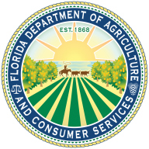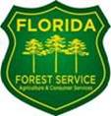

Department of Agriculture and Consumer Services Florida Forest Service Announces Applications for the Southern Pine Beetle Assistance and Prevention Program

Assistance Available for Non-Industrial, Private Forest Landowners

The Florida Forest Service at the Florida Department of Agriculture and Consumer Services is taking applications for the Southern Pine Beetle (SPB) Assistance and Prevention Program from non-industrial, private forest landowners beginning Friday June 14, through Wednesday, July 31.

The program, supported through a grant by the U.S. Department of Agriculture (USDA) Forest Service, offers an incentive payment for landowners who conduct a first pulpwood thinning and partial cost reimbursement for prescribed burning, planting longleaf pine and slash pine and mechanical underbrush treatments.

The program is limited to 44 northern Florida counties located within the range of the southern pine beetle.

Qualified landowners may apply for no more than two approved practices per year. Projects must cover at least 10 acres and funding requests may not exceed $10,000.

All qualifying applications received during the submission period will be evaluated and ranked for approval.

To obtain application forms and more information on program requirements and procedures, contact the local Florida Forest Service office at 638-6250 located on Jackson Ave in the Ag building. Information and forms also available on the internet at
www.floridaforestservice.com/forest_management/fh_insects_spb_prevention_program.html

