4H HSR 02
Nassau County
FLORIDA 4-H
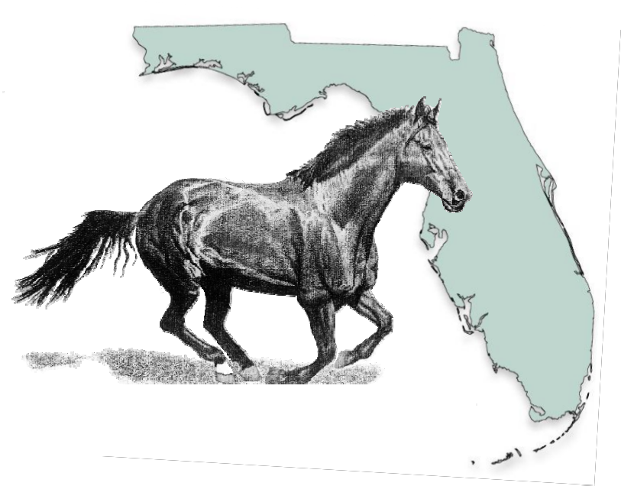Horse Project Record Book

Due
3/31!

Name

Years in Club Work

Address
Name of Club

County
Leader

Date of Birth
# of Years in This Project

COOPERATION EXTENSION SERVICE • IFAS • UNIVERSITY OF FLORIDA

PHILOSOPHY AND GOALS OF THE FLORIDA 4-H HORSE PROGRAM

The purpose of the 4-H Program is to provide young people an opportunity to participate in a series of activities designed to improve citizenship, sportsmanship, horsemanship, character, competitive spirit, discipline and responsibility, while creating an atmosphere for learning and awareness of the life around us.

If one takes time to study this statement, the goals and implications are awesome. It is not anticipated that a child would progress at the same rate for all of these objectives; it is expected that, given the proper motivation and good leadership by leaders, parents and agents, there would be improvements in all areas. Many times, recognition by the 4-H’er that they could improve in these areas is a significant accomplishment.

Most 4-H’ers electing this project will already have a significant interest in, and even a passionate love, for the animal. It is the leaders’ responsibility to utilize this interest to accomplish the project objectives. Though the objectives may be arranged in a different order, you will notice the first objective is not horsemanship. Horsemanship, in the broadest sense, is an important facet of the
4-H horse program, but it should be understood that the horse is only a tool to be used in the development and education of the child. There are over 50 major project areas available in 4-H, and all of them have as objectives to make better citizens of youth, to increase their knowledge in a particular subject matter area and to inspire them to explore other areas.

Horse shows are not the major objective of this program, and any leader or agent that professes this, either out of actual belief or to persuade someone to join a 4- H club, is certainly in error. In doing this, they would most certainly be setting themselves, and the club, up for disappointment and possible failure. This is not to minimize the importance of horse shows in helping to achieve our goals, but it must be understood we are in the business of education. There are many opportunities to show elsewhere and it is quite possible there will be many youth in a club that are not interested in showing. They may be interested in one or more of the many forms of tail riding, rodeoing, breeding and production or other activities involving the use of a horse.

When thinking about the horse program and its objectives, one should certainly realize that participation in horse judging, public speaking and method demonstrations is extremely helpful in achieving said goals. Participation in these activities can help a youth improve in many areas, as well as gain a better education.

In summary, there is a need for all aspects of the current 4-H Horse Program, and it is hoped that you as leaders and agents, will encourage participation of your club members in all these areas.
4-H HORSE MANAGEMENT PROJECT

Instructions

All members who own or manage one or more horses or ponies may keep this project record. It should be kept in an updated, neat and accurate manner. This may be the only project
taken or the member may also enroll in additional 4-H projects including the progressive riding projects. This project may be repeated as many times as desired.

Requirements

1. Be a 4-H member.

2. Select, manage and care for one or more animals. Ownership is recommended but not required. (Note special rules for shows, events, etc.)

3. Follow directions of Project Leaders and Extension Agents.

4. Participate in activities and events related to the project

5. Keep an accurate and up-to-date record book.
INVENTORY

Horses or Ponies you own or use as project animals at start of project year.

Name of Horse | Sex | Age | Color | Breed | Weight | Height | Value or  Lease Cost
Sheza Shadow | Mare | 12 | Black | Quarter | 1000 | 14.3 | $1,400

(1) TOTAL $

Horses and Ponies you own or used as project animals at the end of the project year.
*If you lease, the amount will be zero.

Name of Horse | Sex | Age | Color | Breed | Weight | Height | Value*
Sheza Shadow | Mare | 13 | Black | Quarter | 1000 | 14.3 | $1,500

(2) TOTAL $
TACK " EQUIPMENT " SUPPLIES

Beginning Inventory Closing Inventory*

Article | Cost or  Value
Youth Western Saddle | $600.00
*Be sure to depreciate when appropriate.
Article | Cost or  Value
Youth Western Saddle | $600.00

(3) TOTAL Value $
(4) TOTAL Value $

If additional space is needed, attach separate page(s).
PURCHASES

Use this page to list all of your purchases for the year. It should include horses, tack, equipment, grooming supplies, apparel and any other items you purchased this project year. *If an item has current value, it should also be included in closing animal (2) or equipment (4) inventory as an asset.

Date | Item Purchased | Purchase Price | Current  Value *
8/2/96 | 16 oz. Show Sheen | $12.65 | $0.00

(5) TOTAL $
HEALTH CARE

VACCINATION RECORD DEWORMING RECORD
Name | Date | Vaccine Type | Route | Cost |  | Name | Date | Product | Route | Cost
Shadow | 9/5/96 | Fluvac EWT | IM | $6.50 |  | Shadow | 9/5/96 | Zimecterin | Paste | $10.95

(6) TOTAL $
(7) TOTAL $

BREEDING RECORD

Dam’s Name | Sire’s Name | Date(s) Bred | Date Due | Stud Fee
Sheza Shadow | Gators Dude | April 1-4, 1995 | 3/1/96 | $400.00

(8) TOTAL $

FOALING RECORD

Dam’s  Name | Sire’s  Name | Date  Foaled | Sex | Weight | Foal’s  Name | Description | Condition
Sheza  Shadow | Gators  Dude | 3/5/96 | Filly | 105 lbs. | Hope Filly | Buckskin with left sock | Excellent!

Health Care Expenses Continued on Next Page
HEALTH CARE - CONTINUED
Name | Date(s) | Symptoms or  Event | Treatment | Cost
Shadow | 9/1/96 | Cinch Sore | Wound Salve | $2.00

FARRIER RECORD HEALTH RECORD

Name | Date(s) | Work Done | Cost
Shadow | 9/1/96 | Routine trim | $12.00

(9) TOTAL $
(10) TOTAL $

(11) TOTAL HEALTH CARE EXPENSES $
ADD LINES 6 THROUGH 10

7
FEEDING-RELATED EXPENSES

CONCENTRATE HAY

Name | Dates | # Days | Type of  Concentrate | Lbs./Day | Cost* |  | Dates | Type of Hay | Lbs/Day | Cost*
Shadow | January | 31 | 3# 12% Sweet  3# 12% Pellets | 6 | $31.75 |  | January | Coastal | 6 | $18.60

(12) TOTAL $
(13) TOTAL $

*If feed or hay expenses are included in boarding fee, list amounts but not costs.
Feeding-Related Expenses Continued on Next Page
FEEDING-RELATED EXPENSES CONTINUED

PASTURE MINERAL/SALT
Dates | Type Of Mineral/Salt | Form | Cost
Feb-Mar | PDQ Supplement | LOOSE | $13.00

Dates | Pasture Type | Hours/ Day | Cost
Jan-Mar | Bahia | 10 | $175.00

(14) TOTAL $
(15) TOTAL $

(16) TOTAL FEEDING-RELATED EXPENSES $
Add lines 12 through 15
Type | Quantity | Disposal Method | Cost
Shavings | 3 Bales | Compost pile for pasture fertilizer | $12.75

BOARDING EXPENSES BEDDING SUMMARY

Place | Month | Description | Cost
Equine Hilltop | Jan-Mar | Full Board | $900.00

(17) TOTAL $
(18) TOTAL $

SHOW-RELATED EXPENSES

Event | Mileage/Gas | Hotel | Entry Fees | Stall Fees | Trainer  Fees | Lesson  Fees | Total Cost
State Horse Show | $72.00 | $225.00 | $65.00 | $50.00 |  |  | $412.00
Aug/Sept Lessons |  |  |  |  |  | $198.00 | $198.00

(19) TOTAL $
INCOME SUMMARY

Labor Summary: Duties, Hours Worked, Salary  (Board Trade…) | Prizes/Awards/Gifts | Value
Part time job at stables, 10 hrs/wk, trade for boarding rebate |  | $175.00/month*3mo.=  $525.00

(20) TOTAL $

Animals Sold | Tack/Equipment Sold | Other Income (manure, pony rides….) | Value
 | Garage Sale- used tack |  | $31.00

(21) TOTAL $

(22) TOTAL INCOME RECEIPTS $
YEAR-END BUSINESS ACCOUNT

Value of horse(s) at start of project year (1) | $
Value of all tack, equipment and supplies on  Hand at start of project year (3) | $
Cost of purchases for the year (5) | $
Cost of health-related expenses (11) | $
Cost of feeding-related expenses (16) | $
Cost of boarding and bedding expenses (17, 18) | $
Cost of show-related expenses (19) | $

A. TOTAL EXPENSES $

Value of horse(s) at end of project year (2) | $
Value of all tack, equipment and supplies on hand at end of project year (4) | $
Total Income Receipts (22) | $

B. TOTAL RECEIPTS $

NET PROJECT EXPENSE/INCOME $
(Subtract A from B to find figure)

TIME INVESTED IN CARE OF HORSE(S) AND EQUIPMENT

Sep Oct Nov Dec Jan Feb Mar Apr May Jun July Aug Total

Hours spent grooming, feeding & general care
Hours spent riding, driving, training and lessons
Hours spent on tack care and repair

Comments:

13
PROJECT PHOTOGRAPHS
Include photos with captions that reflect what you do with your horse and/or how you care for it.

14
PROJECT PHOTOGRAPHS

15
Beginning of the year status and plans:

Describe the facilities where you keep your horse(s).

Outline prior training of your horse(s).

Define training objectives for your horse(s) for the year.

Describe any professional help or expert advice you have available and expect to use.
End of the year status:

In regards to your training objectives and plans to utilize professional help or advice on the previous page, list and describe your progress and achievements towards these objectives.

PROJECT STORY

Tell the story of your project. Include items such as goals and benefits achieved, things you learned, unforgettable experiences, project growth, leadership and citizenship activities and things your club did during the project year.

If additional space is needed, please attach separate page(s).
List activities, contests, awards, field trips, clinics, demonstrations, etc.:

EVENT/ACTIVITIES DATE REMARKS

This is to certify that has successfully completed this project.

4-H Leader Date

Extension Agent
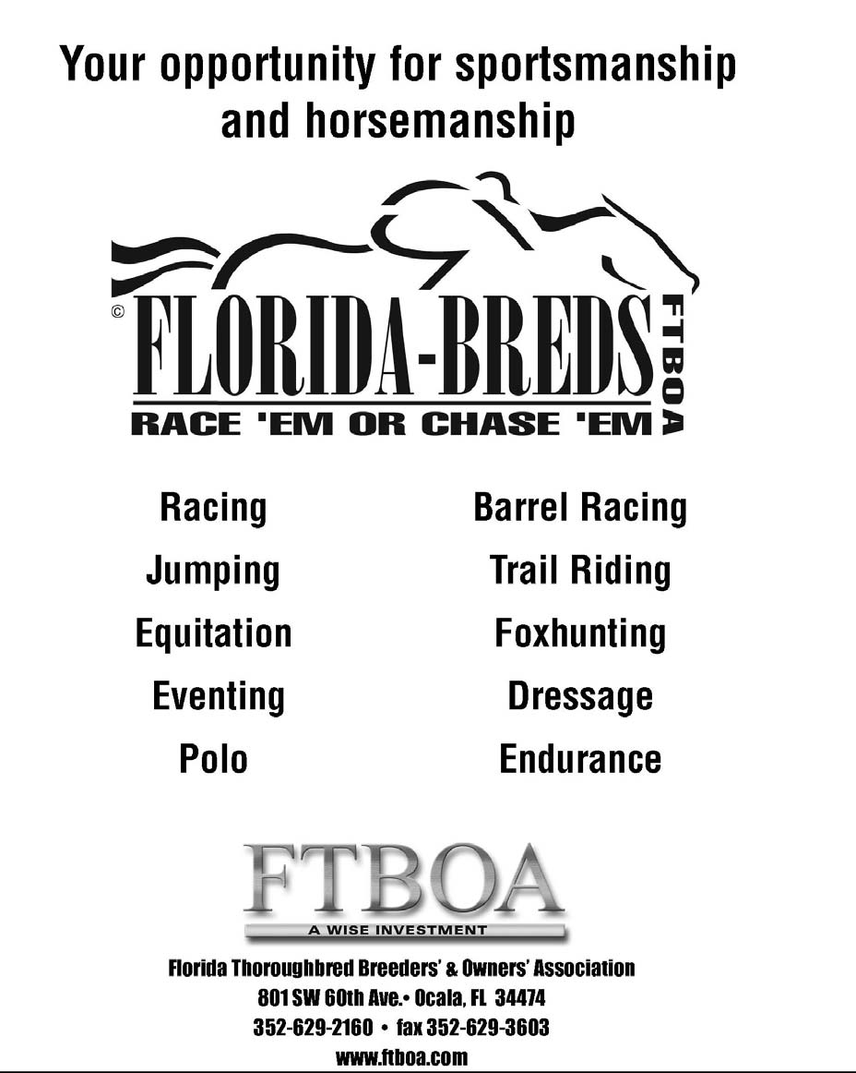

COOPERATIVE EXTENSION SERVICE, UNIVERSITY OF FLORIDA, INSTITUTE OF FOOD AND AGRICULTURAL SCIENCES, Larry R. Arrington, Director, in cooperation with the United States Department of Agriculture, publishes this information to further the purpose of the May 8 and
June 30, 1914 Acts of Congress; and is authorized to provide research, educational information, and other services only to individuals and institutions that function with non-discrimination with respect to race, creed, color, religion, age, disability, sex, sexual orientation, marital status, national origin, political opinions, or affiliations. Single copies of extension publications (excluding
4-H and youth publications) are available free to Florida residents from county extension offices. Information about alternate formats is available from IFAS Communication Services, University of Florida, PO Box 110810, Gainesville, FL 32611-0810. Original Publication Date, June 1995. Revised July, 2002. Revised June, 2007.

