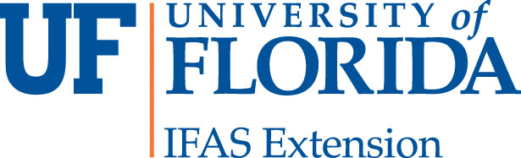

_____________________________________________________________________________
Nassau County Extension Office
543350 U.S. Highway #1
Callahan, FL 32011
Tel. (904) 530-6351
rljordi@ufl.edu
http://nassau.ifas.ufl.edu/

ITEM 3

MG OVERVIEW TEST (ANSWERS WILL BE FOUND IN ITEM 1)

DIRECTIONS: Please circle the letter indicating your answer and return this test along with Item 2 (application) by Friday, 5pm May 31, 2019.

- The Master Gardener Program is sponsored by:
  - The University of North Florida
  - Florida Department of Agriculture and Consumer Services
  - IFAS (Institute of Food and Agriculture Sciences)
  - Florida Division of Plant Industry (DPI)

- The Cooperative Extension Service was created by a legislative act called:
  - The Morrill Act (1862)
  - The Smith-Lever Act (1914).
  - The Hatch Act (1887).
  - Larson Act (1898).

- The Cooperative Extension Service is funded by:
  - The Federal Government
  - The State of Florida
  - The County of Nassau
  - All of the above

- Nassau County Master Gardener Volunteers are required to volunteer how many hours of public service during their first year?
  - 30 hours
  - 75 hours
  - 50 hours
  - 80 hours

- Nassau County Master Gardener Volunteers are required to attain how many additional hours of advanced horticulture training to re-certify for additional year of volunteer service?
  - 35 hours
  - 10 hours
  - 25 hours
  - 50 hours

- The main purpose of the Master Gardener Volunteer Program is to increase or extend the service and output of research based information offered by Nassau County Cooperative Extension.
  - True
  - False

- Nassau County Cooperative Service provides information to the community primarily in the areas of:
  - Family and Consumer Information Services
  - 4-H Youth
  - Agriculture
  - All of the Above

- Master Gardener Volunteers make most pesticide recommendations using information generated from:
  - Public sources such as books, magazines, and newspaper article.
  - Personal, practical experience.
  - The Institute of Food and Agricultural Sciences
  - All of the above.

- The title “Master Gardener” is to be used only in association with the UF/IFAS Nassau County Master Gardener Volunteer Program and not for commercial purposes.
  - True
  - False

- Master Gardener Volunteers must abide by the policies set out by UF/IFAS and the Nassau County Extension Office
  - True
  - False

- Nassau County Master Gardener Volunteers are required to provide a minimum of how many volunteer hours to re-certify after their first year of service?
  - 35 hours
  - 75 hours
  - 50 hours
  - 80 hours

- After attending all the classes and passing the tests, certified Nassau County Master Gardener Volunteers are able to use the name Master Gardener for commercial and business purposes.
  - True
  - False

- Nassau County has only one agriculture agent.
  - True
  - False

- List two topics to be covered at the Master Gardener Training class.
  - _____________________________________

  - _____________________________________

- What do the letters UF/IFAS mean?

__________________________________________________________________________

This application is due back by Friday, June 21, 2019 no later than 5PM.

Mailing Address:
Nassau County Extension 543350 US Hwy 1, Callahan, FL 32011- 6486
or email: rljordi@ufl.edu Phone: (904) 530-6351

