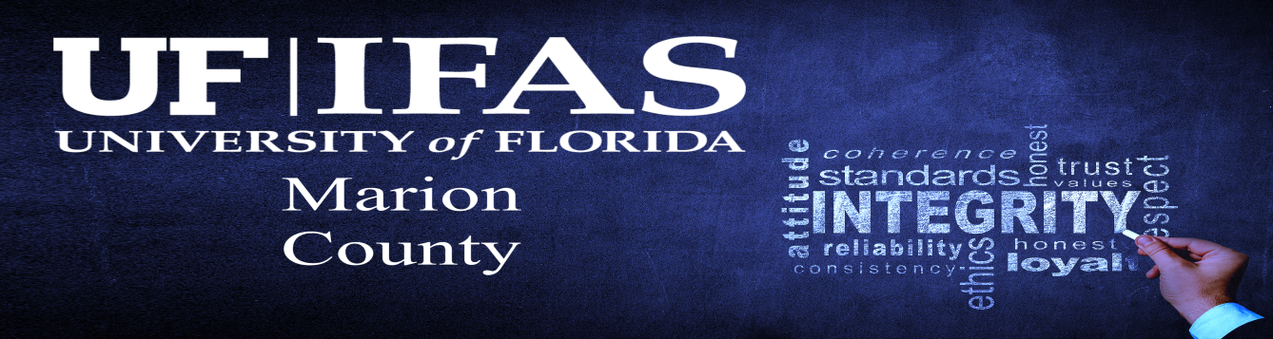
County Extension Departments have a world of knowledge at your fingertips. We are a partnership between the University of Florida (one of Florida’s land grant universities) and the county’s government. In Florida we have 67 counties and all 67 have county extension departments. The citizens within a community often come across issues they really do not understand and need help in solving. The fortunate thing is they are not alone in their quest for knowledge and solutions to their problems. In Marion County our County Extension department works extremely well with the County Board of Commissioners (MCBCC) and the experts from the University of Florida. The MCBCC supply approximately 40% of the funding necessary to employee the agents, staff, and facilities; the University of Florida provides approximately 54% of the funding to support research and agents and the federal government provides an additional 6% of the funding to support the initiatives that have been identified through surveys and community input about issues effecting the economic and personal health of the county residents and its resources.
Here in Marion County, we are fortunate to house 10 county agents whose expertise range from urban horticulture, agriculture and natural resources, youth development, livestock production both small and large, crop production, family consumer science areas of food systems, healthy lifestyles, financial counseling, and Florida Friendly Landscape agent. Agents develop relationships with business and industry as well as homeowners, and residents that call Marion County their home. With these relationships often the agents are able to survey the community to make sure they address the needs our residents are facing. From these SWOT (strengths, weaknesses, opportunities, and threats) analysis the most significant topics are uncovered. It may be a health topic specifically addressing a targeted area with a high number of a specific age range of individuals who are showing high rates of death to heart disease or diabetes. The livestock agents may address economic issues facing industry specific to agriculture pasture management such as which forage is best suited to our environment for cattle or equine here in Marion County. Agriculture is one of Marion Counties largest employers when you count agriculture related businesses that support the industry with over 37,500 employees. Meet our team of agents.
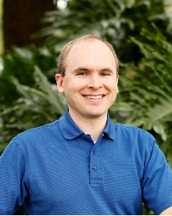
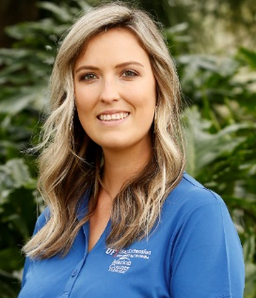
Mark Bailey currently is the Sustainable Agriculture & Food Systems agent. Mark can provide information on crop production (vegetables, fruit, and commercial horticulture production), small ruminants, poultry, and entrepreneurship. Currently he is working with specialist in the crop production areas to identify the best varieties of passion fruit to produce in our climate.
Our large animal production questions can be addressed by Caitlin Bainum. She specializes in forages, equine management, and cattle management. Annually she has an equine institute working with agents in neighboring county to provide scientific research-based information to the producers. She is involved with the University specialist in livestock production and brings their expertise to the county residents.
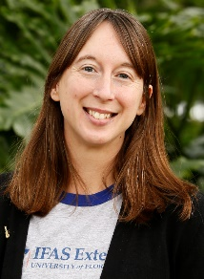
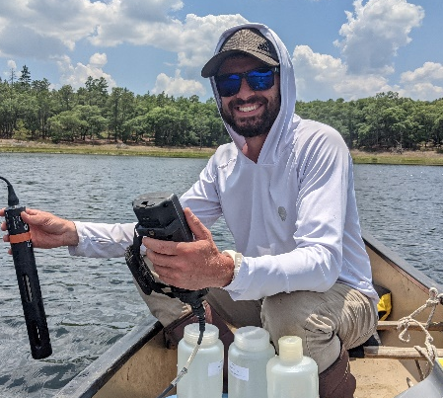
Preserving our natural resources and implementing best management practices to save our clientele money while reserving our natural resources is especially important to Marion County. We are fortunate to have three magnum one springs in Marion County along with numerous other springs, ponds, and lakes. We have thousands of acres in farmlands that are important to the residents of Marion County. The following agents work in areas addressing these needs.
Gabriel Vicari is the Water agent and will be working with farmers in irrigation and Best Management Practices to reduce run off. Additionally, he assists homeowners in septic tank and well water best management and legislative initiatives.
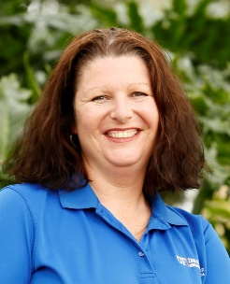
Amanda Marek is our Florida Friendly Landscape agent who works with landscaping and services that reduces the water use and saves our community many gallons of our natural water resources we are so blessed to have. She has saves the county over 1,986,000 gallons of water annually through her educational programs.
Maxine Hunter has a vast knowledge in agriculture and natural resources and is serving in the position as our Ag and Natural Resource agent. She is working with programs to help producers in any concern dealing with conservation. Also, an arborist she can help with issues involving trees, pond management, invasive pests, and weeds.
Family and Consumer Science agent, Rebecca Elliott addresses needs in the nutritional and healthy living area. She has a background in public health and dietician. Using SWAT survey Rebecca has identified areas of high need for programing in diabetics, heart health, and healthy living activities.
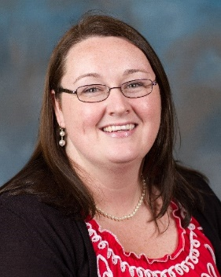
4-H and youth development is an area that benefits us all. Preparing youth to be productive and useful citizens, in addition to developing their knowledge of the agriculture industry, and careers in Science, Technology, Engineering, and Mathematics (STEM) helps build a sustainable economy. Our agents in the 4-H Youth Development area are Chelsea Jones and Crystal McCazzio. Students participate in judging teams, civic activities, Southeastern youth fair projects and a number of self-esteem and character-building activities.
I serve as the Community Resource Development agent and work with making sure the connections between the community and our office are developed. Fostering a relationship that is beneficial to the mission of Marion County Board of County Commissioners and UF/IFAS Extension empowering Marion County citizens for success.

