Northwest Florida
Sponsored by the UF/IFAS
Panhandle Agriculture Extension Team

Beef Conference
& Trade Show

Wednesday, February 10, 2016
Jackson County Agriculture Conference Center
2741 Pennsylvania Ave. Marianna, FL 32448 850-482-9620

Sponsor and Exhibit at the 31st Annual Beef Conference!

If you sell products and services to Beef Cattle Producers in the Florida Panhandle, you won’t want to miss the opportunity to exhibit at this year’s Beef Conference Trade Show.

What is the Beef Conference?
It is a half day, Extension Education Program for cattle ranchers from the Florida Panhandle. The focus changes somewhat each year, but the program is always aimed at improving beef cattle operations in the Southeast. This educational program is a joint effort of County Extension Agents and University of Florida Beef and Forage Specialists.

This year, the program will focus on: Improving Ranch Efficiency for the Long Term. Our speakers will discuss a variety of ideas to improve operational efficiency as ranchers will be facing declining prices. The exact agenda has not been finalized yet, as we are still recruiting a nationally known person to serve as our keynote speaker.

How does the trade show work?
Table Top Displays will be set up on 8 foot tables along the walls of the auditorium. Equipment Displays will be set up just outside the auditorium, in the nearby pavilion. The cost of sponsoring and exhibiting is $150 for either type of exhibit. The program will have designated times for ranchers to visit with the Trade Show Exhibitors: 45 minutes during registration, 30 minutes in the middle of the program, and 1 hour immediately following lunch.

In order to boost interaction between ranchers and exhibitors at the event, exhibitors will be introduced just prior to the Trade Show break. Each exhibitor will be given an opportunity to introduce themselves and the organization they represent. Door prizes are another tool many of our exhibitors use to introduce ranchers to their products. Each participant will be given door prize tickets at registration, so if you would like to give out some product, just bring it with you to the event. Tickets for door prizes will be drawn during lunch.

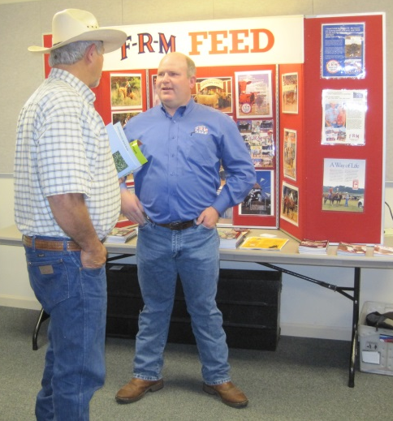
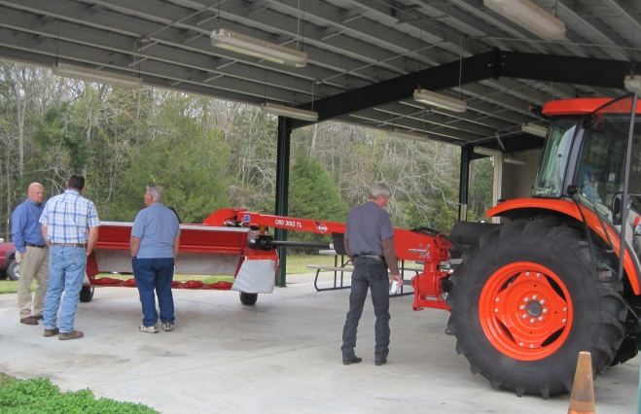

Equipment Pavilion (just outside auditorium)
8 foot Table Top Display

What does my $150 go towards?
The Beef Conference is a non-profit, annual Extension educational program. All of the sponsorship money goes to cover the travel expenses of the speakers, refreshments, snacks, and lunch for everyone in attendance.

Why is it worth my time and money?
120-160 cattle producers from across the Florida Panhandle and Southeast Alabama annually attend the Beef Conference. This type of format has been very successful for the past 30 years. Company representatives will make contacts with numerous beef producers from this region at one event.

Where will the Conference be located?
The Beef Conference and Trade Show will be held in the Jackson County Agricultural Conference Center, located just behind the Jackson County Extension Office. The Extension Office and the Conference Center are located on State Road 276 (Pennsylvania Avenue) 1 mile north of Interstate 10, in Marianna, Florida.

- To get there from I-10, exit at State Road 276 (exit 136) and travel North 1 mile. This is the western Marianna exit. Look for a long tan building with a green metal roof on the left hand side. The Conference Center is at the rear of the building. The best entrance for unloading is the service entrance on the south side of the building. Pavilion access for equipment is the dirt road on the north end of property.

What do I have to do to participate?
Download and complete the exhibit registration form and an email it to demayo@ufl.edu. If you prefer to fax, send to 850-482-9287, but please confirm receipt with a follow up phone call to 850-482-9620. At the website you can also download the specific agenda, and an invoice to use within your company.

Sincerely,

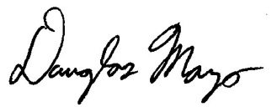
Doug Mayo, County Extension Director
Jackson County Extension

